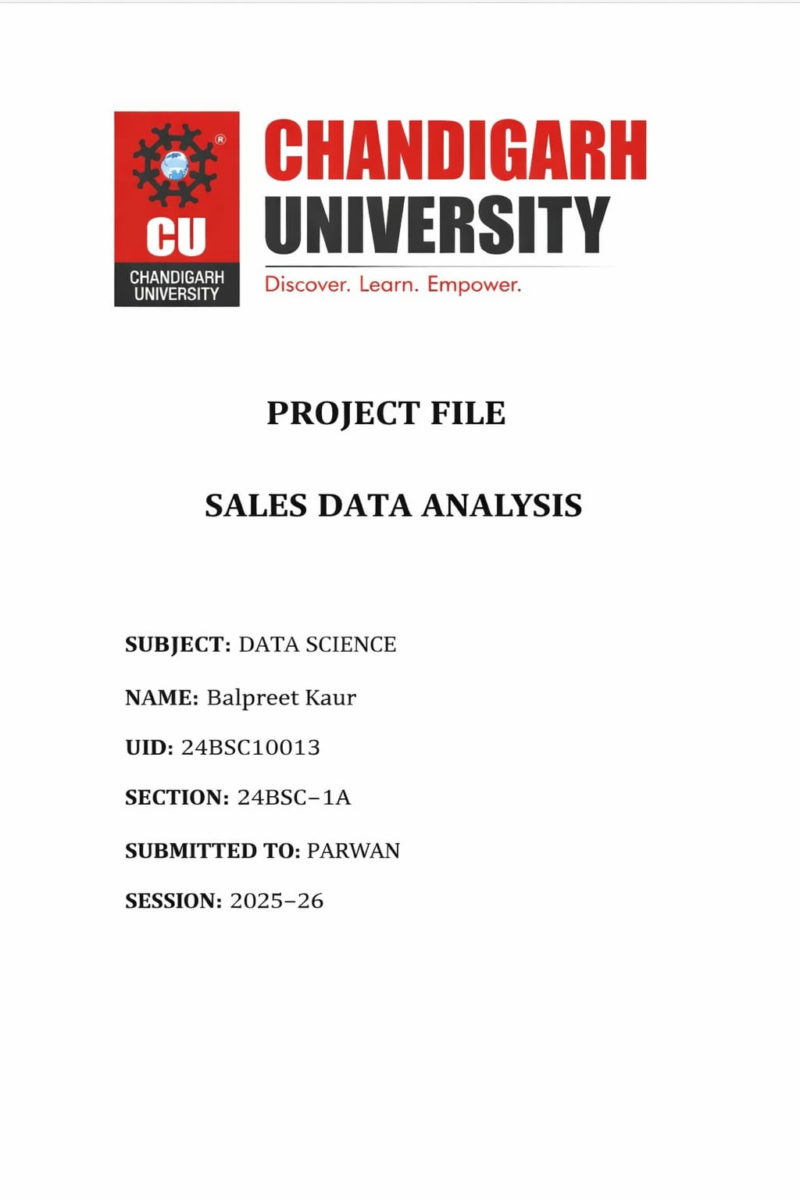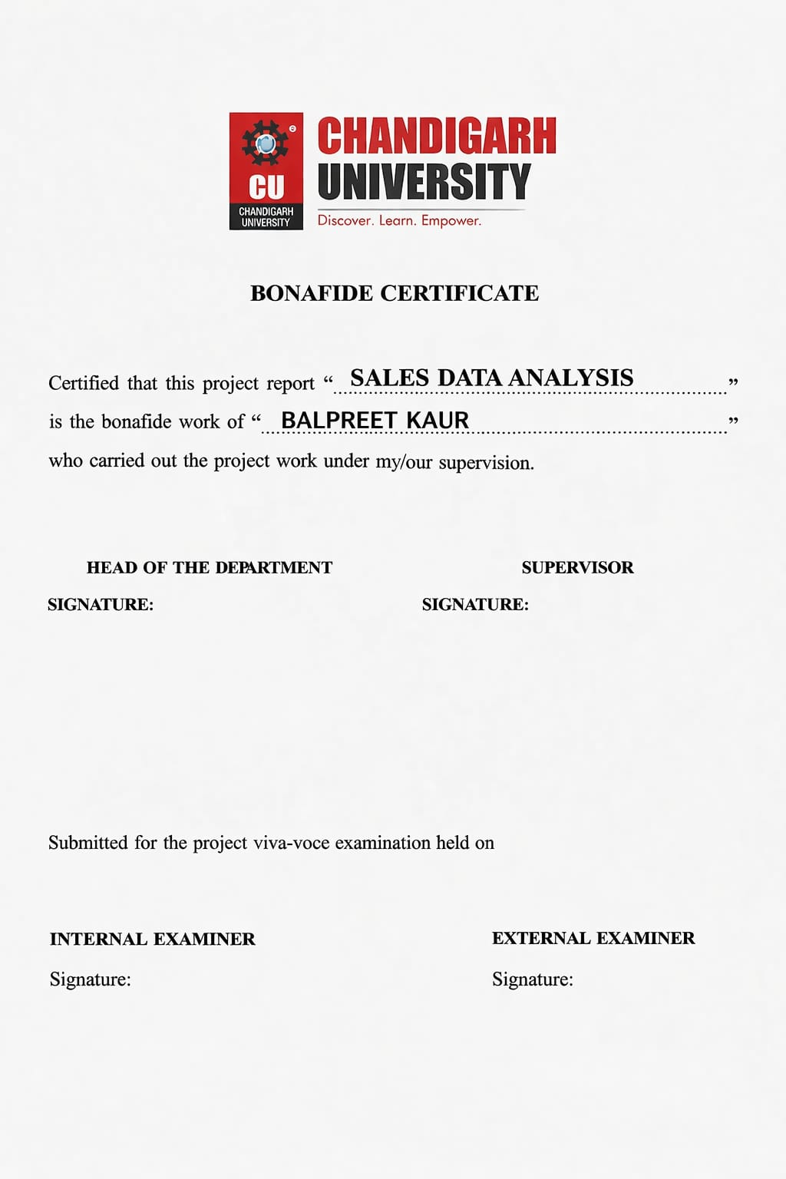🔹Introduction
Sales Data Analysis is a process of examining sales data to understand business performance. Using Microsoft Excel, we can organize, calculate, and visualize data easily.
This project helps in:
- Tracking product performance
- Finding total revenue
- Identifying best-selling products

🔹Objective
- To analyze sales data using Excel
- To calculate total sales and profit
- To identify top-performing products
- To visualize data using charts

🔹 Tools Used
- Microsoft Excel
- Basic formulas and charts

🔹 Dataset (Sample Data)
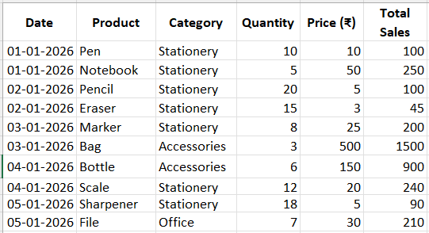
🔹Steps to Perform in Excel
✅ Step 1: Enter Data
- Open Excel
- Create columns as shown above
✅ Step 2: Calculate Total Sales
✅ Step 3: Total Revenue
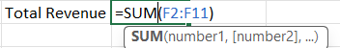
✅ Step 4: Find Maximum Sales
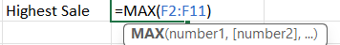
✅ Step 5: Find Minimum Sales
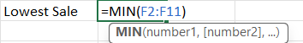
🔹Data Visualization
📊 Charts to Create:
- Bar Chart → Product vs Sales
- Pie Chart → Sales Distribution
👉 Go to:
Insert → Charts → Select Chart Type
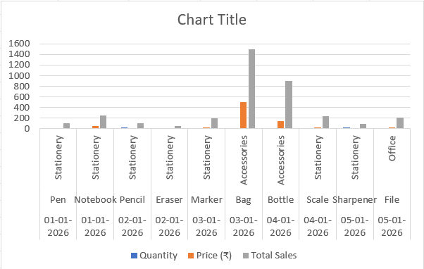

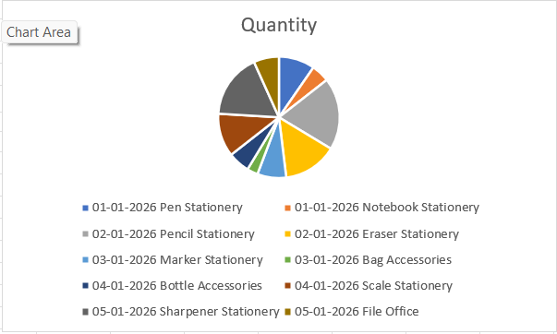
🔹Analysis & Findings
- Identify highest selling product
- Identify least selling product
- Calculate total revenue
- Observe sales trends
Example:
- Notebook gives highest revenue
- Pencil has high quantity sales
🔹 Problem Statement
In many businesses, sales data is collected daily but not properly analyzed. Without analysis, it becomes difficult to:
- Identify profitable products
- Track performance over time
- Make business decisions
This project solves this problem using Microsoft Excel by converting raw data into meaningful insights.
🔹 Scope of the Project
This project can be used in:
- Retail shops 🏪
- Online stores 🛒
- Small businesses
- Student-level data analysis
👉 It is scalable — can handle large datasets in real life.
🔹 Data Preprocessing
Before analysis, data must be cleaned:
✔ Steps:
- Remove duplicate entries
- Check missing values
- Ensure correct data types (numbers, dates)
- Format columns properly
👉 In Microsoft Excel:
- Use Remove Duplicates
- Use Filter option
- Use Text to Columns

🔹 Advanced Excel Features Used
✅ 1. IF Function (Logical Analysis)
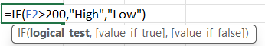
✅ 2. Conditional Formatting
- Highlight highest sales (Green)
- Highlight lowest sales (Red)
👉 Helps in quick visualization
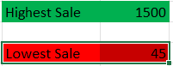
✅ 3. Sorting & Filtering
- Sort products by highest sales
- Filter specific product data
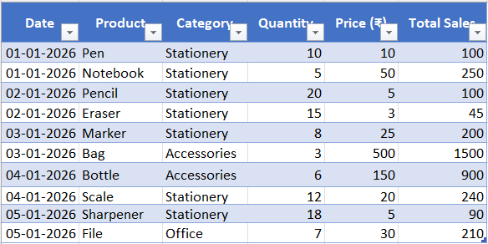
✅ 4. Pivot Charts
- Visualize pivot table data
- Dynamic and interactive

🔹 Advantages of Using Excel
- Easy to use
- No coding required
- Fast calculations
- Powerful visualization tools
🔹 Limitations
- Not suitable for very large datasets
- Limited automation compared to Python
- Manual updates required
🔹 Future Scope
This project can be improved by:
- Using Python for automation
- Adding machine learning for prediction
- Connecting with databases
- Real-time sales tracking
🔹 Real-Life Applications
- Business decision making
- Inventory management
- Customer behavior analysis
- Profit analysis
🔹 Conclusion
This project shows how Excel can be used for basic data analysis. It helps in:
- Better decision making
- Understanding customer demand
- Improving sales strategies

🔹 References
- Microsoft Excel official tutorials
- Online learning platforms
- Classroom notes

